4/28/2025

(Student C00270632) Qadeer Hussain

Supervisor: Paul Barry

Software Development Project Year 4

Final Report

Elderly Care Management System(Care Net)

Table of Contents

Introduction 3

Description of Project 4

Main functionality 5

Screenshots for Care Net 5

Screenshot for Key Server 14

Technologies/Tools Used 15

Technologies used for Care Net 15

Tools used for Care Net 15

Technologies used for Key Server 16

Tools used for Key Server 16

Description of Conformance to Specification Design 16

What was achieved 16

What was not achieved 16

Description of Learning 17

Technical Learning 17

Personal Learning 17

Review of Project 18

What went well 18

What went wrong 18

What is outstanding/missing 18

Starting again 18

Advice for future developers 18

Improvements I had more time 18

Technology Review 18

Acknowledgements 19

Conclusion 19

Table of Figures

Figure 1: System Architecture 4

Figure 2: Login Page 5

Figure 3: Error handling on Login Page 6

Figure 4: Home page 6

Figure 5: Create Patient Profile 7

Figure 6: Search Patient Profile 7

Figure 7: Patient Results 8

Figure 8: View results 8

Figure 9: Search Patient Medical Dashboard 9

Figure 10: Patient Medical Dashboard Results 9

Figure 11: View Medical Dashboard Results 10

Figure 12: Edit Medical Dashboard Results 10

Figure 13: Roster 11

Figure 14: Add Roster Entry 11

Figure 15: Roster Management View 12

Figure 16: Search Care Plan 12

Figure 17: Patient Care Plan Result 13

Figure 18: View Patient Care Plan 13

Figure 19: Edit Care Plan 14

Figure 20: Key Server 14

Figure 21: Ngrok Tunnel for Key Server 15

# Introduction

The purpose of this document is to provide a detailed final report of the Elderly Care Management App. document will reflect on the application development process and the use of technologies, learning outcomes and an overview of the project as a whole.

# Description of Project

The Elderly Care Management System(Care Net), is a secure web application which manages sensitive patient information. Webapp is to be used by nursing home and care homes. At its core, the Care Net application serves as the main interface for both Administrators and Carers, handling all patient data operations through a web interface. The Webapp retrieves the key from the Key server via API calls. The usage of tokens for authentication between the Webapp and the Key Server where all the data is then stored in the Care Net Database. The Key server has its own separate database for encryption keys and API tokens. This multi-tiered approach ensures that patient information remains secure while still being accessible to authorised users.

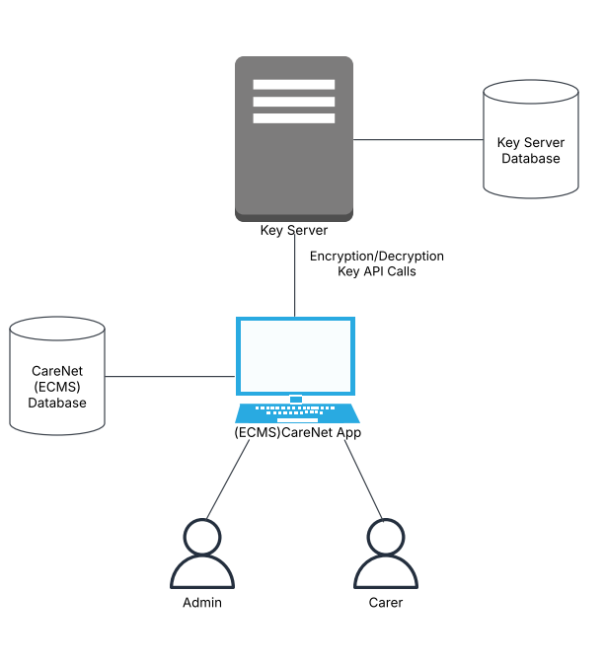

Figure 1: System Architecture

## Main functionality

Below is the core functionality for this project

**User Login:** Only registered users can access the web application. Only Administrators have the authority to create login accounts for Carers.

**Security:** Data encryption and decryption are handled through strong cryptographic methods to ensure the confidentiality and integrity of patient information.

**Patient Profile:** Allows the creation of a secure record containing a patient’s personal details.

**Medical Dashboard:** Enables the secure recording and management of a patient’s medical information.

**Care Planner:** Provides tools to create and manage individualized care plans for patients registered in the system.

**Roster:** Allows Administrators to assign Carers to patients and schedule their daily care activities.

## Screenshots for Care Net

Here are some screenshots of the application in use.

Figure 2: Login Page

This is the Login page. It’s the first page you land on when accessing the Care Net web application. Users must enter a valid username and password to gain access. Only registered Carers and Adminstartors whose accounts have been created by an Admin are permitted to log in. This ensures that only authorised personnel can view and manage patient sensitive data.

Figure 3: Error handling on Login Page

This is the login in screen demonstrating error handling. When users log in with incorrect credentials the error message is displayed.

Figure 4: Home page

After logging in you get to the home page. The home pages serves as the main navigation of the Care Net web application. It presents a quick access menu with several options. Additionally, the Enter maintenance mode button stops the application to perform a re-encryption process. Once re-encryption is completed, the application automatically resumes normal operation.

* Patient Profile: Manage Patient personal information.
* Medical Dashboard: Manage patient medical information.
* Roster: Assign Carer to Patients for the day.
* Care Planner: Manage care plans for patients.

Figure 5: Create Patient Profile

The Create patient profile page allows for users to register patients into the Care Net system. Once the form is completed and submitted the data is encrypted and securely save in the database.

Figure 6: Search Patient Profile

The Search Patient Profile allows users to quickly search for patient within the Care Net system. Users can search by Name or Date of Birth. After submitting the system retrieves and displays matching patient profiles.

Figure 7: Patient Results

This screenshot shows an example of search results for a patient named John Doe. The results are displayed in the results card.

Figure 8: View results

After clicking on the patient from the search results shown in Figure 7, users are able to view the full details of the selected patient. Here the user can edit or delete the patient record. The functionality provides a convenient way to keep patient information up-to-date or to remove records.

Figure 9: Search Patient Medical Dashboard

The Search Patient Medical Dashboard allows users to quickly search for patient medical dashboard within the Care Net system. Users can search by Name or Date of Birth. After submitting the system retrieves and displays matching patient profiles.

Figure 10: Patient Medical Dashboard Results

This screenshot shows an example of search results for a patient’s medical dashboard. The results are displayed in the results card.

Figure 11: View Medical Dashboard Results

After clicking on the patient from the search results shown in Figure 10, users are able to view the full details of the patient's Medical Dashboard, provided that medical information already exists. If no medical records are available, the system will display a prompt asking the user if they would like to add new medical details.

Figure 12: Edit Medical Dashboard Results

Within this dashboard, users can edit, and manage important information such as Medications, Medical History, Allergies and Medical Files. This functionality ensures that patient medical records are always accurate, up-to-date.

Figure 13: Roster

The Roster Management page allows users to view and manage the daily roster within the Care Net system. This page displays a table listing scheduled shifts, including the Day, Shift Time, Assigned Carer, Patient and action.

Figure 14: Add Roster Entry

After clicking add roster entry, the user is directed to this page to create a new roster entry. Admin can select the Day, define the Shift Time, and choose both a Carer and a Patient from dropdown menus populated with existing records.

Figure 15: Roster Management View

This screenshot shows an example of the roster in the Care Net system. In this example, a shift has been scheduled for Monday from 8 a.m. to 4 p.m. with Carer Maria Wood for Patient John Doe. User is able to delete the roster entry after completion.

Figure 16: Search Care Plan

The Search Patient Care Plan allows users to quickly search for patient care plan within the Care Net system. Users can search by Name or Date of Birth. After submitting the system retrieves and displays matching patient profiles.

Figure 17: Patient Care Plan Result

This screenshot shows an example of search results for a patient’s care plan. The results are displayed in the results card.

Figure 18: View Patient Care Plan

After clicking on the patient from the search results shown in Figure 17, users are able to view the full details of the patient's Care Plan, provided that the care plan already exists. If no care plan are available, the system will display a prompt asking the user if they would like to add new care plan.

Figure 19: Edit Care Plan

Within this Care Plan, users can edit, information such as Daily activities and any notes taking during the day. Activities can be added, modified, or removed as needed, and any completed tasks can be ticked off.

## Screenshot for Key Server

Here are some screenshot of the key server in use.

Figure 20: Key Server

The Key Management System provides a web interface for managing API tokens and encryption keys. Users can generate new API tokens for authentication and create or rotate key when needed.

Figure 21: Ngrok Tunnel for Key Server

The Key Server runs locally on a laptop, while the Care Net web application is deployed on PythonAnywhere. To enable secure communication between the remote Care Net app and the locally hosted Key Server, Ngrok is used. Ngrok creates a secure tunnel to the local Key Server, exposing it to the internet with a URL.

## Technologies/Tools Used

### Technologies used for Care Net

* Framework: Django
* Front End: Bootstrap, HTML, JS
* Backend: MariaDB and MYSQL, Python,
* Libraries: Cryptography, Secrets

### Tools used for Care Net

* GitHub
* Jet Brains IDE (PyCharm)
* MariaDB
* PythonAnywhere

### Technologies used for Key Server

* Framework: FastAPI
* Front End: Bootstrap, HTML, JS
* Backend: MariaDB, Python,
* Libraries: Secrets

### Tools used for Key Server

* GitHub
* Jet Brains IDE (PyCharm)
* MariaDB
* Postman
* Runs Locally using NGROK (for tunnelling localhost to public URL)

# Description of Conformance to Specification Design

This section outlines how the project conforms to the original specification and design. It includes a summery of the functionality achieved, not achieved and potential improvements that could be made to enhance the system further.

## What was achieved

* Cryptography
* User Login
* Creating Patient Profile
* Viewing Patient Profile
* CRUD Medical Dashboard
* CRUD Roster
* CRUD Care Plan

## What was not achieved

# Description of Learning

## Technical Learning

## Personal Learning

# Review of Project

## What went well

## What went wrong

## What is outstanding/missing

## Starting again

## Advice for future developers

## Improvements I had more time

## Technology Review

# Acknowledgements

I would like to thank my project supervisor Paul Barry for his continued support throughout the duration of the project. Our weekly meetings were extremely valuable, providing continuous feedback that kept me on track and helped me adhere to the project schedule. Paul was also available outside of our scheduled meetings via email to assist with any questions or issues that arose.

Finally I would like to extend my thanks to all the lectures in SETU who have thought and supported me during my four years at SETU.

# Conclusion